# t6: Performance check for the modules of urbanladder using jmeter on aws cloud

## JMETER TESTING IN AWS

### Architectural Diagram

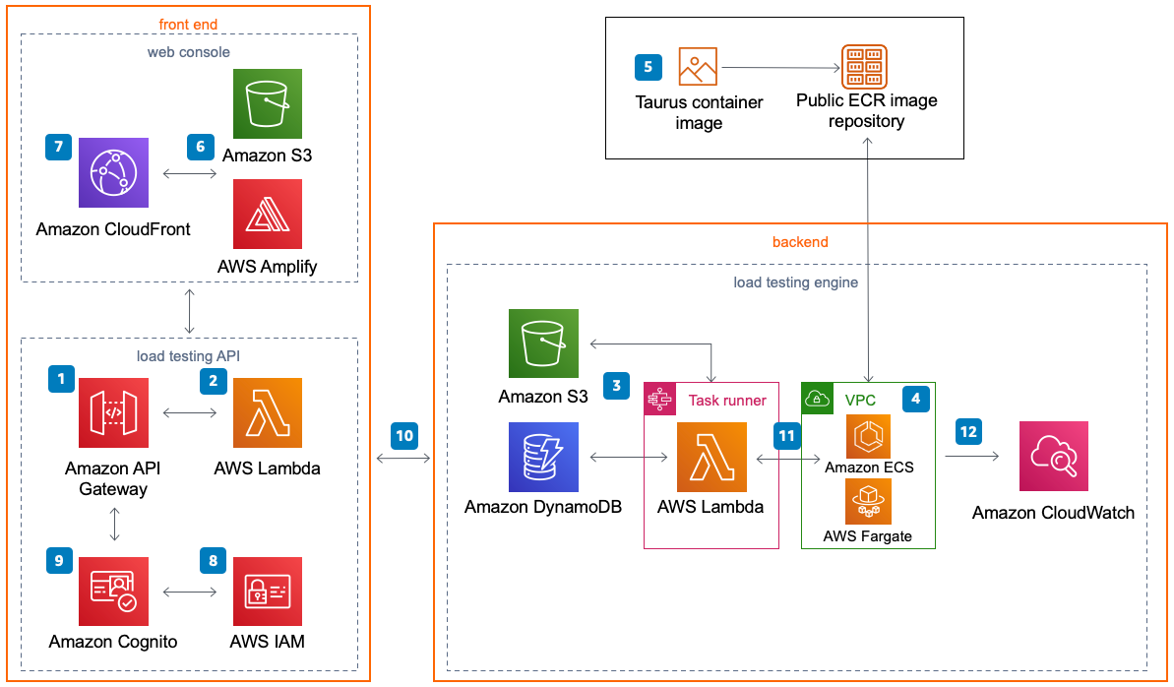

**STEPS:**

* **Create a CloudFormation Template**
* <https://aws.amazon.com/solutions/implementations/distributed-load-testing-on-aws/>
* Follow this link

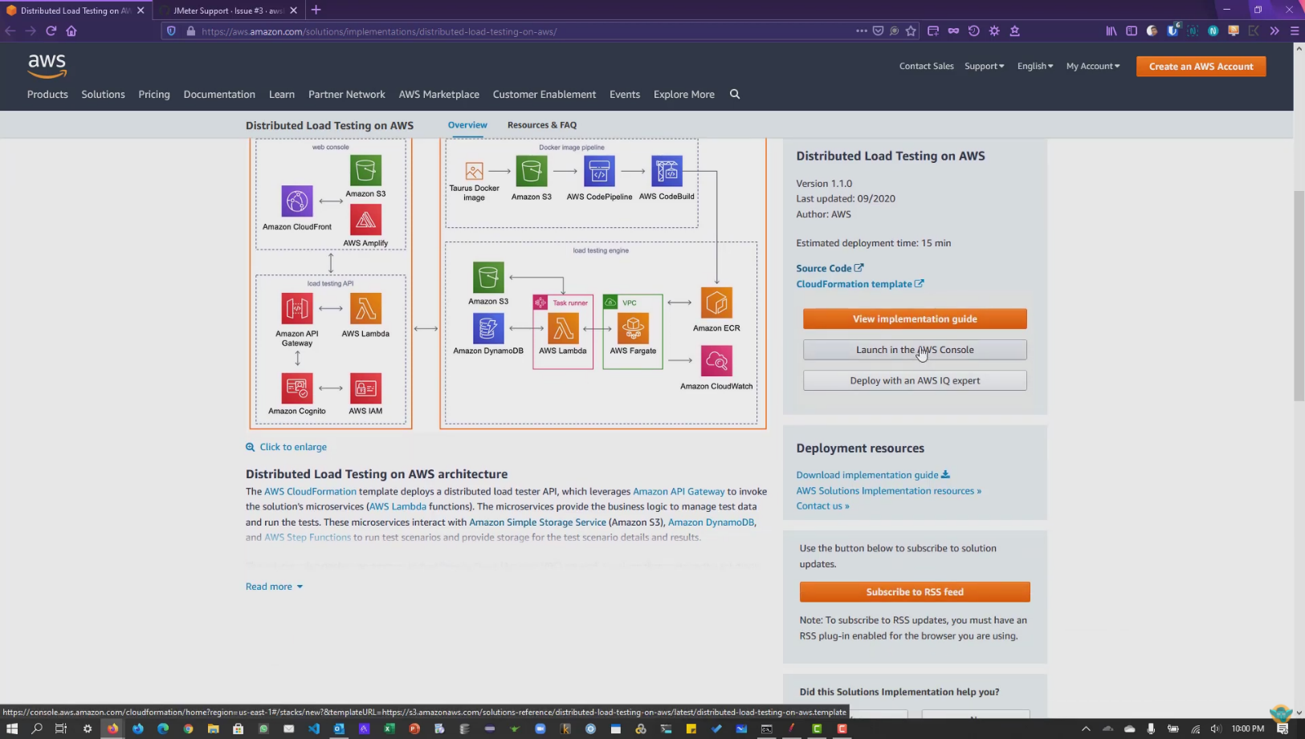



* **Specify template**

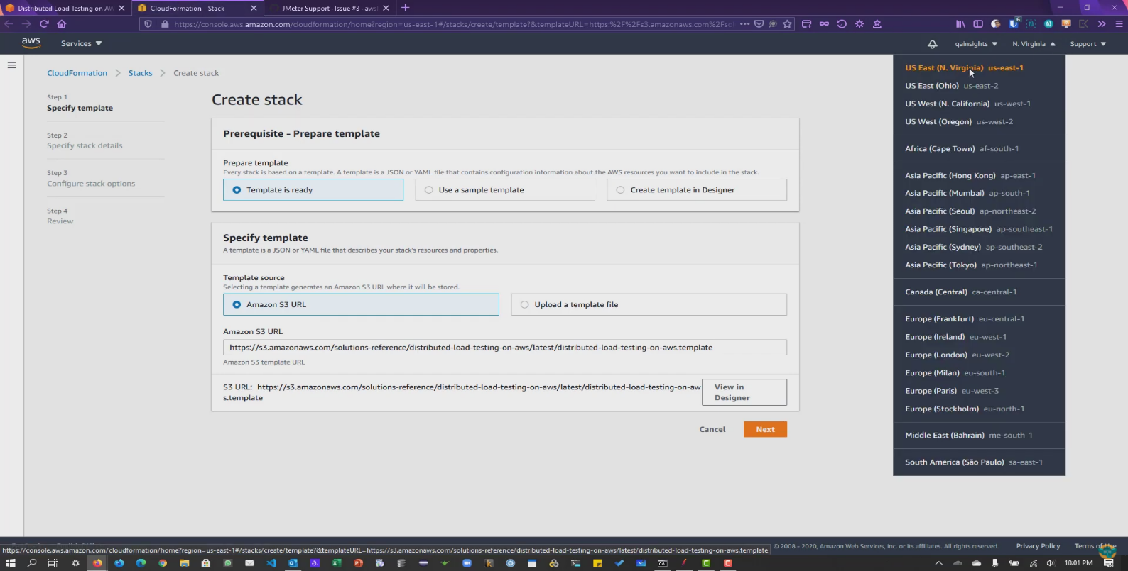



* **Specify stack details**



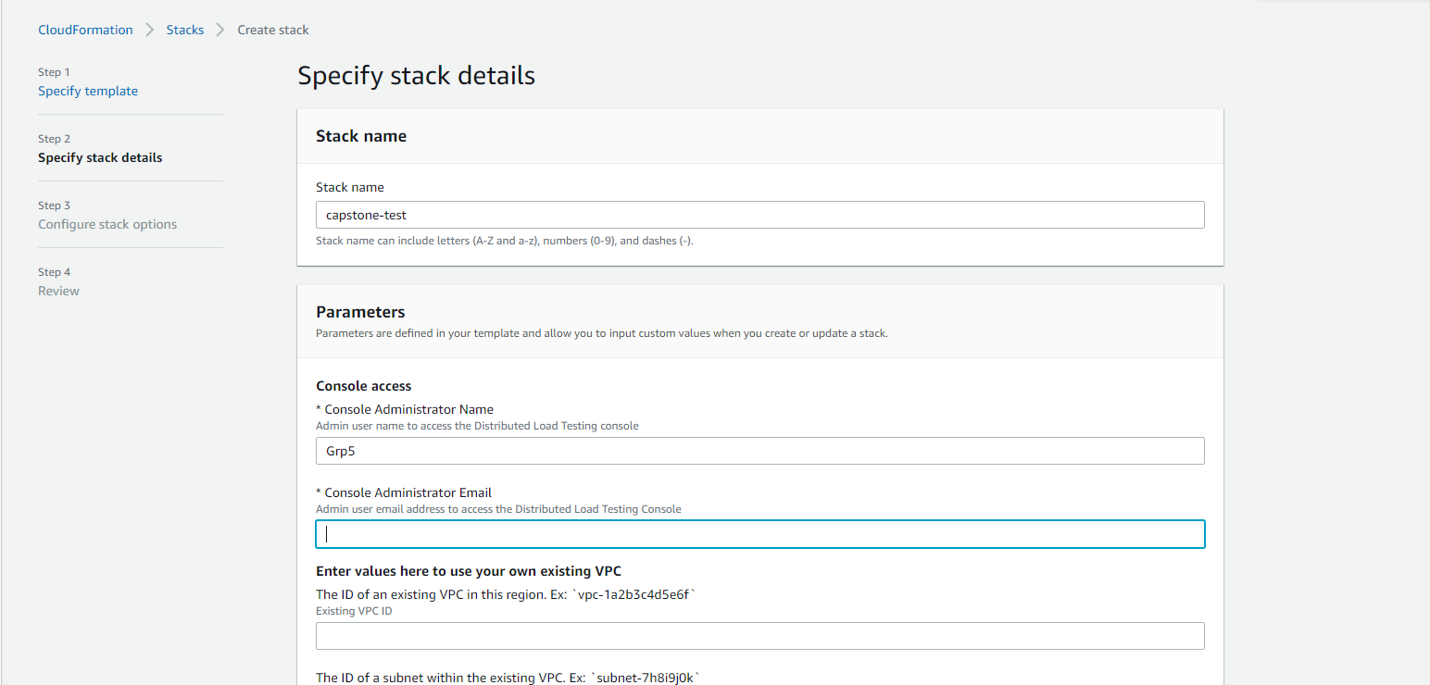



* **Configure Stack options (set as default)**

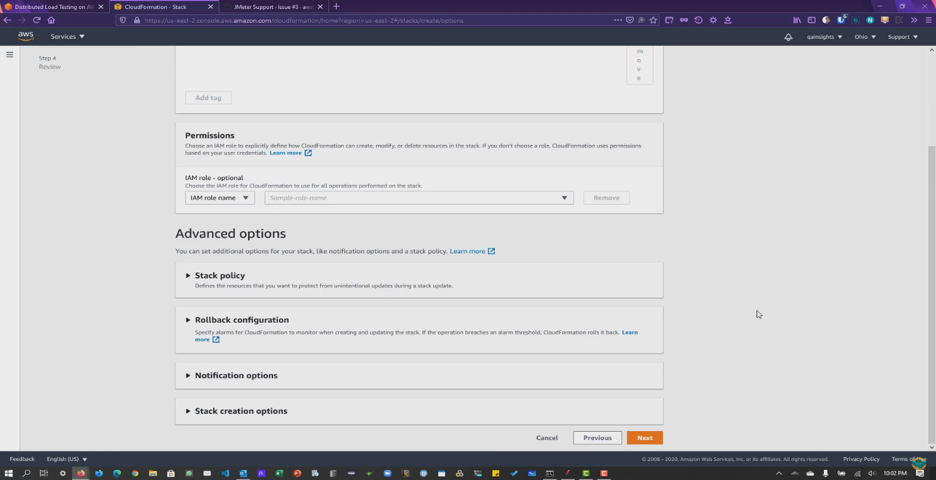



* **Review and create the stack**

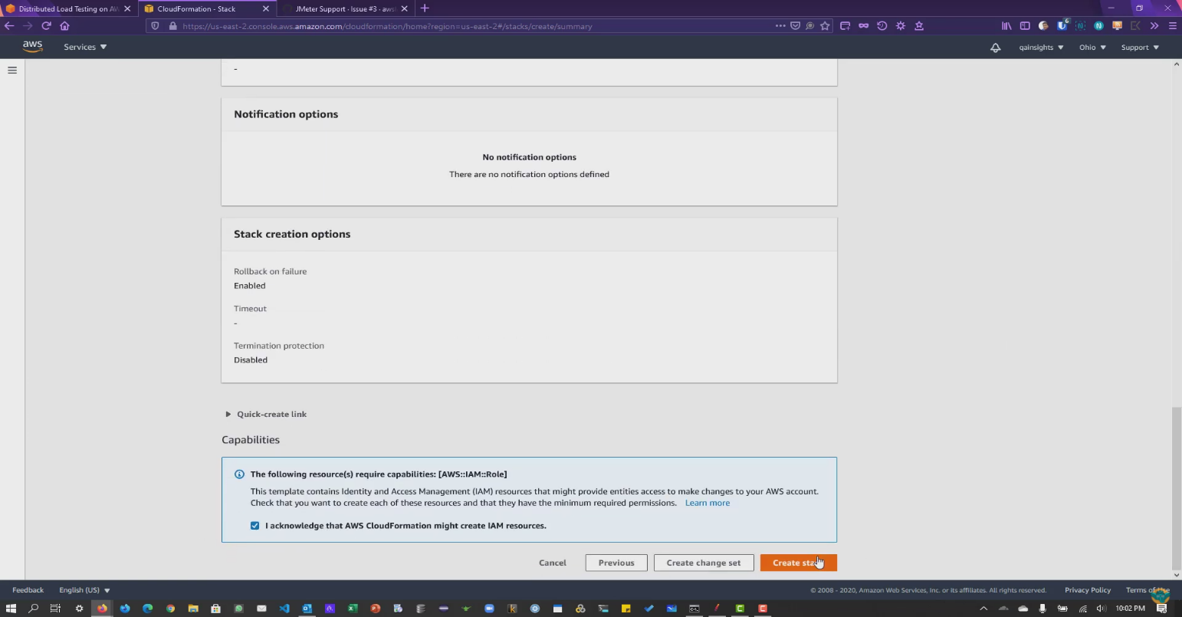

* Wait until the stack is created it may take some time
* After the stack got created go to the output section

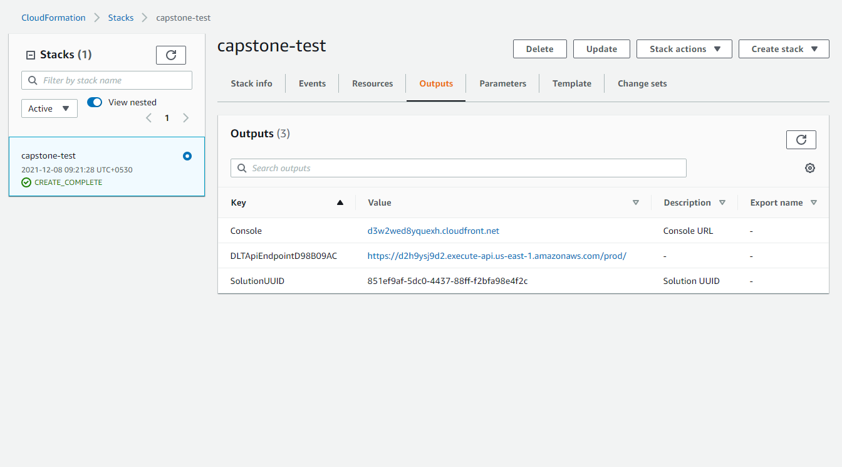

* Click on the console link
* Login to JMeter console you will get the credentials in mail

**This is the Load testing console**

* Upload a sample jmx file u done in JMeter in script file

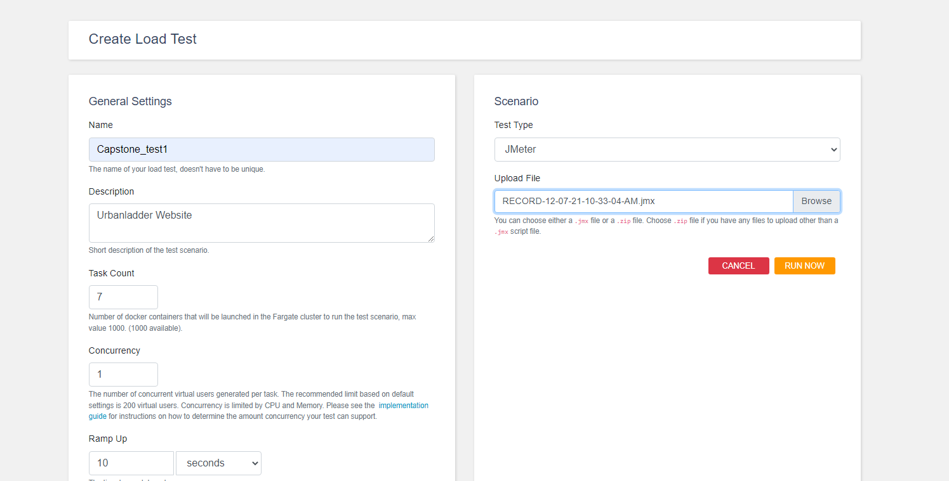



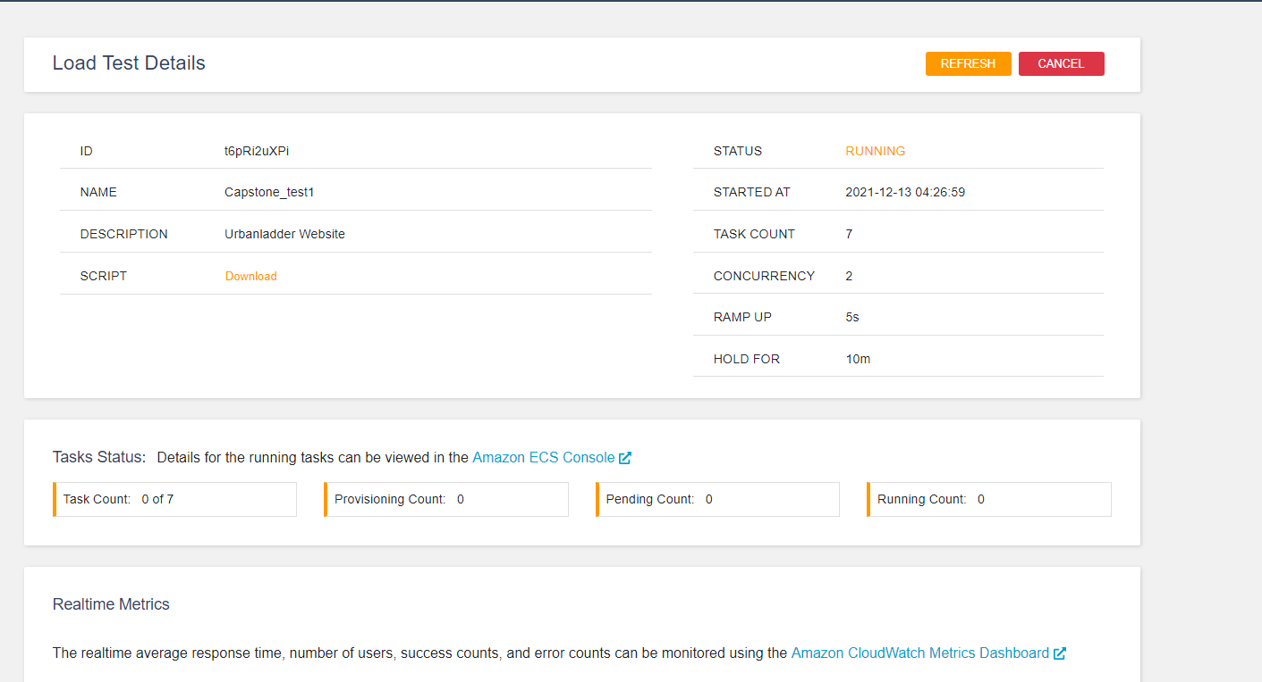

**Explore Ecs console and CloudWatch Metrics dashboard to explore more details about the test.**

**It may take some times to see the test results,**

